Constellations of the Churnet
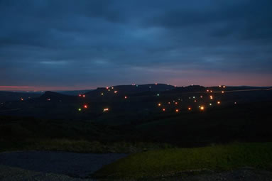
The 'Borderland constellations' were created by members of Borderland Voices working with Charles Monkhouse during 2009. This is a part of Charles's 'Night Stations' project (visit www.nightstations.co.uk for more information)
Through a series of workshops the group explored the night skies, the stars and their associated mythologies before creating their own imaginary constellations. These images shows the 'constellations' drawn as a light installation across the Staffordshire Moorlands landscape on Saturday 17th October 2009 .
The installation was visible for just the one evening with best views from the Mermaid Inn on Morridge Edge looking towards Ramshaw Rocks and the Roaches. Visitors to the pub were bowled over by the display and people driving along the road stopped to find out what was going on.
Quite apart from Charles's artistic input, the display needed a great deal of legwork by many people, installing the lights beforehand and then safely removing them afterwards and Borderland Voices is most grateful to everyone involved.

